Passé Composé with être
Study Guide
For the quiz next week on Wed, Jan 11th:
You will need to know which verbs use avoir, and which verbs use être. You will need to know how to conjugate avoir and être, and how to form the past participles for –er, -ir, and –re verbs, and how to make them agree with the subject for être verbs.
Grammar Notes:
In French, the passé compose (past tense) is used with either avoir or être. Most French verbs use avoir. The following is a list of verbs (and their derivatives) that require être:
aller to go
arriver to arrive
descendre to descend / go downstairs
(redescendre to descend again)
entrer to enter
(rentrer to re-enter)
monter to climb
(remonter to climb again)
mourir to die
naître to be born
(renaître to be reborn, born again)
partir to leave
(repartir to leave again)
passer to pass
rester to stay
retourner to return
sortir to go out
(ressortir to go out again)
tomber to fall
(retomber to fall again)
venir to come
(devenir to become
parvenir to reach, achieve
revenir to come again, come back)
These are all verbs that involve a certain kind of movement.

Verb agreement:
- When you use avoir, the past participle does not have to agree with the subject (except when the direct object is before the verb; we will learn about this in Unit 7B).
For all verbs conjugated with être, the past participle MUST agree with the subject in gender and number.
Examples:
Il est allé. - He went. Elle est allée. - She went.
Ils sont allés. - They went. Elles sont allées. - They went.

- Verbs are conjugated with être because they are intransitive (have no direct object). However, six of these verbs can be used transitively (with a direct object), and when this happens, they need avoir as the auxiliary verb. (We will learn these six verbs in a later chapter)

Here are various ways to remember/memorize which verbs use être:
- La Maison d'être
The French teach être verbs with a visual: La Maison d'être. Draw a house with a door, stairs, windows, etc. and then label it with the être verbs. For example, put someone on the stairs going up (monter) and another going down (descendre). Or look at the picture on the next page. The ٤tre verbs all involve motion to and from a house, and within the house.

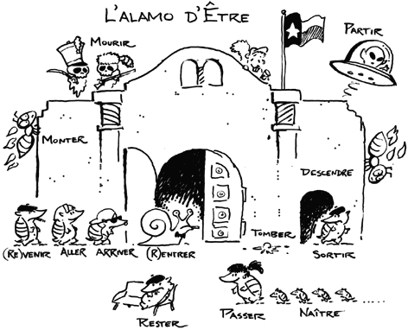

There are three acronyms that are commonly used to remember être verbs. Strangely, none of them includes passer, which is an être verb when used intransively.

- DR & MRS VANDERTRAMP

This is perhaps the most popular mnemonic device for être verbs in the United States. Personally, I find DR & MRS VANDERTRAMP redundant since it includes some derivatives, but if it works for you, go for it.
Devenir
Revenir
&
Monter
Rester
Sortir

Venir
Aller
Naître
Descendre
Entrer
Rentrer
Tomber
Retourner
Arriver
Mourir
Partir

- ADVENT

Each letter in ADVENT stands for one of the verbs and its opposite, plus one extra verb, for a total of thirteen.
Arriver - Partir
Descendre - Monter
Venir - Aller
Entrer - Sortir
Naître - Mourir
Tomber - Rester
Retourner

- DRAPERS VAN MMT13

Each letter in DRAPERS VAN MMT stands for one of the 13 verbs.
Descendre
Rester
Aller
Partir
Entrer
Retourner
Sortir

Venir
Arriver
Naître

Mourir
Monter
Tomber
---------
13 total verbs (not including verbs that have a suffix: like entrer and rentrer)

